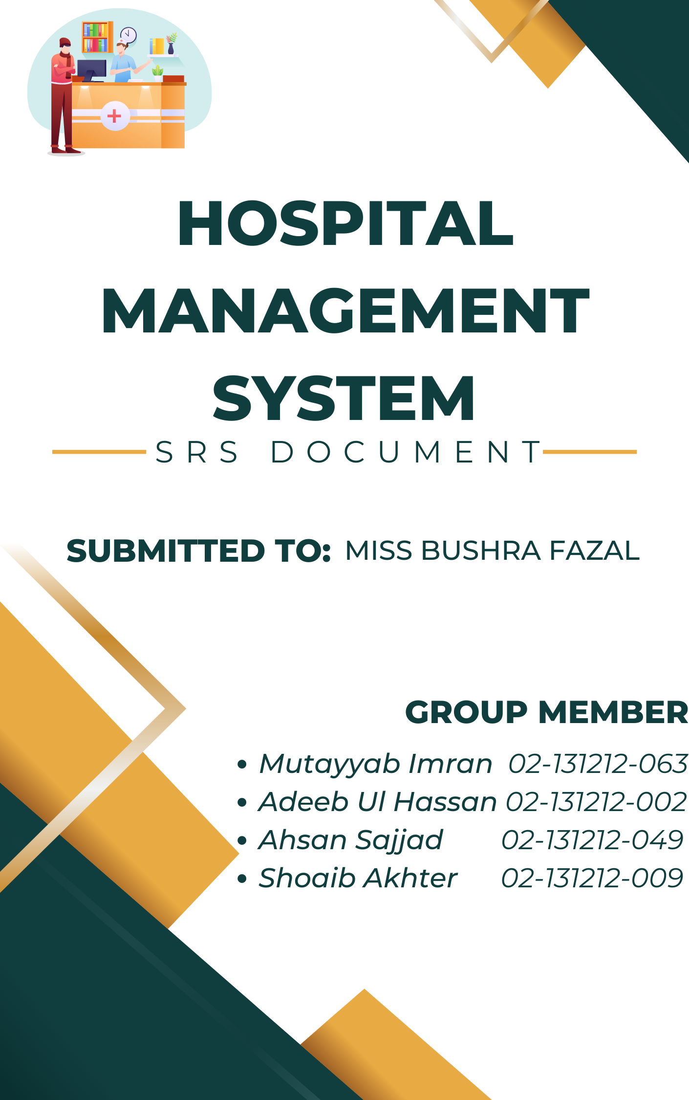

Contents

**Introduction** 3

Purpose 3

Project Scope 3

1.4 SUCCESS METRICS: 4

1.4.1 Average Length of Stay 4

1.4.2 Time to service 4

1.4.3 Hospital Incidents 4

1.4.5 Patient Readmission Rate 4

1.4.6 Compliance 4

1.4.7 Data Quality and completeness 4

Definition, Acronyms, Abbreviations: 4

Intended audience 5

**Standard Overview** 5

Product Scope 5

Product Prespective: 6

References 6

Product Function 6

Graphical Representation of Product Function 8

User Classes and Characteristics 9

**SPECIFIC REQUIREMENTS** 9

**Operating Environment** 9

**External Interface Requirements** 9

User Interface 9

**Hardware Interface** 9

Display Unit (LED/LCD): 9

Laser Printer (B/W) 9

Wi-Fi router 10

**Software Interface** 10

**Communications Interfaces** 10

**Functional Requirements** 11

Domain Specific Requirements 11

Condition Specific Requirements 12

**System Features** 13

USE CASE DIAGRAM 13

SEQUENCE DIAGRAM 23

ER DIAGRAM 24

**Non-Functional Requirements** 25

Security 25

Safety Requirements 25

Performance Requirements 25

Maintainability 25

Reliability 25

Business Rules 25

Testability Requirements 26

Usability Requirements 27

Documentation Requirements 27

# **Introduction**

My project Hospital Management system includes registration of patients, storing their disease details into the system. My software has the facility to give a unique id for every patient and stores the details of every patient. The Hospital Management System can be used by entering respective username and password. It is accessible either by an administrator or receptionist. Only the respective person can add data in the database. The data can be retrieved easily. The interface is very user-friendly. The data are well protected and data processing is very fast, accurate and relevant.

# Purpose

A hospital management system is a software designed to manage all the areas of a hospital such as medical, financial, administrative and the corresponding processing of services.

# Project Scope

Daily functions like patient registration, managing admission and overall management of various departments can be easily performed with higher accuracy after the installation of hospital software. The modules of hospital management software are user-friendly and easy to access.

**✓** The proposed software product is the Hospital Management System (HMS).The system will be used to get the information from the patients and then storing that data for future usage.

✔The current system in use is a paper-based system. It is too slow and cannot provide updated lists of patients within a reasonable timeframe.

**✓** The intentions of the system are to reduce over-time pay and increase the number of patients that can be treated accurately.

Requirements statements in this document are both functional and non-functional.

# 1.4 SUCCESS METRICS:

# 1.4.1 Average Length of Stay

This metric tracks how long a patient stays at a hospital, from time admitted through discharge. Average length of stay is important because it can provide a measure of efficiency within each hospital..

# 1.4.2 Time to service

This metric measures the time it takes from when the patient arrives at the hospital to when the patient receive healthcare services, including the amount of time it takes to see either a nurse or a doctor. Time to service is important because it provides useful information on a hospital’s ability to provide prompt services to its patients.

# 1.4.3 Hospital Incidents

This metric measures the ability of a hospital to provide quality care for its patients. Tracking hospital incidents is important because it provides data on the quality of care patients are receiving via a specific hospital.

1.4.4 Patient Satisfaction

This metric measures the satisfaction level of a patient’s hospital stay and care provided. If patient satisfaction is high, patients may recommend the hospital to family and friends. This metric may also have an impact on how hospitals market themselves.

# 1.4.5 Patient Readmission Rate

This metric provides data on the number of patients that must return to the hospital after a short period of being discharged.

# 1.4.6 Compliance

This metric measures the compliance of the HMS with relevant laws, regulations, and industry standards, to ensure that the system meets legal requirements and protects patient data.

# 1.4.7 Data Quality and completeness

This metric measures the quality of the data collected and stored in the HMS, and the completeness of the records and the extent to which they accurately reflect the patients' conditions.

# Definition, Acronyms, Abbreviations:

**CFD**: - Context Flow Diagram

**DFD**: - Data Flow Diagram

**IDE**: - Integrated Development Environment

**Java**:- Platform Independent,

**OOP**:- Object Oriented Programming

**SQL**: - Structured Query Language

**SRS**: - Software Requirement Specification

# Intended audience

The intended audience of this document would be the client and specific employees like Manager and Receptionist, consultants and System Operators, and project team, supervisor with the objective to refer and analyze the information. The SRS document can be used in any case regarding the requirements of the project and the solutions that have been taken. The document would finally provide a clear idea about the system that is building.

# **Standard Overview**

# Product Scope

Currently, Al-Hayaat Medical Centre is using manual system to handle the hospital process. Every operation was being done manually. As system is file-based, as management face difficulties to save records. It causes an issue for organizing information and processing operations.

As HMS will be covering all basic processes that will resolve the issues that are being faced by management. This system will move around patient, doctors and hospital staff. It would handle patient records, Staff members records and their salaries, pharmacy management, laboratory management, finance management, Insurance management, stock management, Quality assurance, facilities management, and appointment/scheduling management.

Our goal is to make a client satisfied system by full filling the client requirements and improving the current manual system with client needs.

**Patient registration:** This function allows patients to be registered in the system, with the ability to capture demographic, insurance, and contact information.

**Appointment scheduling:** This function allows patients to schedule appointments with physicians, nurses, and other healthcare providers, and provides reminders to the patients.

**Electronic Health Records (EHR):** This function captures patient's medical history, vital signs, lab results, diagnoses, and treatment plans, allowing healthcare providers to make informed decisions about patient care.

**Medication management:** This function allows for the management of medication orders, dispense, and refill, and provides alerts for drug interactions and allergies.

**Billing and insurance management:** This function allows for the management of billing and insurance claims, including claims submission, payment processing, and account management.

**Clinical decision support:** This function provides guidance on diagnosis, treatment, and care management, to help ensure that patients receive appropriate and effective care.

**Reporting and analytics:** This function provides reporting and analytics capabilities, such as generating data-driven reports on patient demographics, health outcomes, resource utilization, and financial performance.

**User access management:** This function controls user's access to the system, by defining their roles and permissions, and maintains their accounts and their credentials.

**Telemedicine:** This function allows healthcare providers and patients to communicate and interact remotely, such as virtual consultations, remote monitoring, and tracking treatment progress

# Product Prespective:

This project gives the procedural approach how a patient gets treatment, details about date of treatment and finally depending on different criteria like room allocated, lab reports, treatment and medicine taken…. Etc, how billing is calculated. During billing health care facility is also considered.

# References

Lauesen, S, (2003), *Task Descriptions as Functional Requirements*, IEEE Computer Society,

Available: <http://www.itu.dk/~slauesen/Papers/IEEEtasks.pdf>

# Product Function

**Patient Module:**

1. Add patients
2. Update Info.
3. Delete and Search patients.
4. Assign Patient ID

**Doctor Module**:

1. Update or add doctors
2. Search availability

**Accounting**:

1. View daily payments
2. Transfer salaries
3. Expenses manage
4. Calculate sales tax
5. Print salary sheets

**Pharmacy**:

1. Order Medicines
2. Stock management
3. Generate Sales Bills
4. Add/update medicines

**Laboratory:**

1. Search Reports
2. Request Labs Equipment
3. Upload Reports Online
4. Print Reports

**Quality Assurance**:

1. Receive Feedback online
2. Auto Summarize Feedbacks
3. Report to Admin
4. Record Performance on Individual.

**Employees Module:**

1. Add/Update Information.
2. Assign Employee ID

**Appointment/Scheduling:**

1. Book Online Appointment
2. Appointment SMS alert

**Cash/Billing Unit:**

1. Manage Cash
2. Print receipts and bills
3. Calculate services price
4. Accept banks/insurance cards

**Stock:**

1. Add items
2. Update items
3. Track stocks availability
4. Order vendors online

**Facility management:**

1. Track room availability
2. Alert for survey
3. Patient Request necessary items

**Insurance Management**

1. Check insurance information
2. Manage insurance agencies
3. Alerts if issue

**Helpdesk:**

1. Request any info help
2. Auto reply on similar queries.
3. Generate receiving on query.

**Campus Security:**

1. Receive security complains
2. Update security guidelines
3. Manage cameras recording
4. Scan thumbs

# Graphical Representation of Product Function

# User Classes and Characteristics

The system will be used in the hospital. The administrators, front-desk staff will be the main users. Given the condition that not all the users are computer-literate. Some users may have to be trained on using the system.

# **SPECIFIC REQUIREMENTS**

# **Operating Environment**

Software requirements

* Windows 7 or above operating system
* JRE 1.8
* MySQL server

Hardware Requirements

* Core i3 processor
* 2GB Ram (4GB advisable)
* 1TB hard disk space in Server Machine

It describes all the details that the software developer need to know for designing and developing the system. This is typically the largest and most important part of the document.

# **External Interface Requirements**

# User Interface

User interface is designed in a user-friendly manner and the user, in another end he has to give the order, for that he will interface with keyboard and mouse.

# **Hardware Interface**

* OS – Windows XP
* Hard disk – 80 GB
* RAM – 1 GB
* Keyboard – Standard QWERTY keyboard for interface
* Mouse – Standard mouse with 2 buttons

These requirements are basic requirements to run product which is acceptable for patients.

# Display Unit (LED/LCD):

Display is for to display the product.

# Laser Printer (B/W)

Simply this device is for printing bills and view reports.

# Wi-Fi router

Wi-Fi router is used to for internetwork operations inside of a hospital and simply data transmission from pc’s to sever.

# **Software Interface**

Front end – Window Foam (C#)

OS – Net Beans IDE 6.9.1 3)

Database – SQL Server 2005

Back end – C# language

# **Communications Interfaces**

* NIC (Network Interface Card) - Itis a computer hardware component that allows a computer to connect to a network. NICs may be used for both wired and wireless connections.
* CAT 5 network cable- for high signal integrity
* TCP/IP protocol-Internet service provider to access and share information over the Internet
* Ethernet Communications Interface- Ethernet is a frame-based computer network technology for local area networks (LANs)
* Ubiquitous, easy to set up and easy to use. Low cost and high data transmission rates.

**Electronic Health Records (EHR) systems:** The HMS should be able to integrate with the hospital's existing EHR system, to ensure that patient information is accurate, complete, and up-to-date. This typically involves interfaces for exchanging patient demographic, clinical, and billing information.

**Laboratory systems:** The HMS should be able to interface with laboratory systems to request and receive lab test results.

**Pharmacy systems:** The HMS should be able to interface with pharmacy systems to request and receive medication orders, track medication dispense and refill, and receive medication interaction alerts.

**Radiology systems:** The HMS should be able to interface with radiology systems to request and receive diagnostic imaging studies, and view images.

**Biometric devices:** The HMS should be able to interface with biometric devices such as fingerprint scanners, facial recognition, and others, to ensure accurate patient identification and secure access to the system.

**Payment gateways:** The HMS should be able to interface with payment gateways to process patient payments, and ensure that billing and insurance information is accurate and up-to-date.

**Telemedicine devices:** The HMS should be able to interface with telemedicine devices, such as remote monitoring devices, to enable remote consultations and patient monitoring.

# **Functional Requirements**

* Administration module:-

This module enables the user to insert, update, view and delete the patient information.

* Patient module:-

PatientId,Name,Age,Sex,Address,Phone Number,Weight

This module has following 2 sub modules:-

* Inpatient module:-

This sub module is used to store information about patients who were admitted in the hospital on doctors advice.

PatientId, Dept depending on disease, Doctor, Room no, Date of admitted, Advance, Date of discharge.

Updation like deletion and modification is done.

* Outpatient module:-

PatientId,New_Case,Old_Case,Date,Deptdependingon disease,Doctor .

Updation like deletion and modification is done.

* Lab module:-

This module used to store or produce the laboratory reports.

PatientId, Weight, Category, Doctor, Inpatient/Outpatient, Date.

Updation like deletion and modification is done.

* Billing module:-
* Inpatient module:-

PatientId, doctors charge, health card amount, room bill, medicine bill, total amount, No of days, Service charge, Operation theatre,Nursing care, Lab bill

# Domain Specific Requirements

**Compliance with healthcare regulations:** The HMS should comply with all relevant regulations, such as the Health Insurance Portability and Accountability Act (HIPAA) in the United States, which sets standards for protecting the confidentiality, integrity, and availability of electronic protected health information (ePHI).

**Electronic health records (EHR) integration:** The HMS should be able to integrate with the hospital's existing EHR system, to ensure that patient information is accurate, complete, and up-to-date.

**Clinical decision support:** The HMS should include features such as drug interaction and allergy checks, to ensure that patient care is safe and effective.

**Appointment and scheduling management:** The HMS should include features such as appointment scheduling and cancellation, patient check-in, and patient wait time tracking, to ensure that patients are seen in a timely manner.

**Billing and insurance management:** The System should include features such as insurance claim submission, patient billing, and account management to ensure that financial transactions are accurate and efficient.

**Reporting and analytics:** The HMS should include reporting and analytics capabilities, such as generating data-driven reports on patient demographics, health outcomes, resource utilization, financial performance, etc.

**Communication with external systems:** The System should include the ability to communicate with external systems such as laboratories, pharmacies, and other healthcare providers to ensure that patient information is shared seamlessly, and patient care is coordinated effectively.

# Condition Specific Requirements

**Chronic disease management:** For conditions such as diabetes and heart disease, the HMS should include features such as monitoring vital signs, tracking medication adherence, and providing patient education resources.

**Oncology care:** For cancer patients, the HMS should include features such as tracking treatment progress, managing side effects, and coordinating care with specialists.

**Obstetric and gynecologic care:** For women's health, the HMS should include features such as appointment scheduling, tracking menstrual cycles, and managing prenatal care.

**Pediatric care:** For pediatric patients, the HMS should include features such as growth and development tracking, vaccination management, and coordinating care with specialists.

**Geriatric care:** For elderly patients, the HMS should include features such as fall risk assessments, tracking cognitive status, and coordinating care with specialists.

**Mental Health management:** For mental health, the HMS should include features such as mental health assessments, medication management, and coordinating care with specialists.

**Telemedicine:** The HMS should also consider features for telemedicine, that enables patients to receive care remotely, such as virtual consultations, monitoring vital signs, and tracking treatment progress.

# **System Features**

# USE CASE DIAGRAM

USE CASE SCENARIOS

|  |  |
| --- | --- |
| **Name** | **Add patient** |
| Description | This function get details of a patient and add record to the patient file and generate a patient registration number |
| Actors | receptionist |
| Pre-conditions | The operator should login with user account |
| Main flow of events | 1. User selects “add patient entry “at home page 2. Patient entry form displayed 3. Users enter data to required fields 4. User selects “Add entry” button 5. “Successfully record added” message displayed. 6. System generates a patient Id and display. |

|  |  |
| --- | --- |
| **Name** | **View patient records** |
| Description | This function view the patient personal information and visits records. |
| Actors | Receptionist, Admin, doctor, patient, lab engineer |
| Pre-conditions | Patient must register to the system |
| Main flow of events | 1. User selects “view patient info” 2. Enter Patient ID in search 3. You can now access the patient info. |

|  |  |
| --- | --- |
| **Name** | **Add cash and Generate bills** |
| Description | This function calculate and add cash to account cash and print bill of paid cash |
| Actors | Receptionist |
| Pre-conditions | The patient must be added to system. |
| Main flow of events | 1. User select the “services” tab 2. Select the medical services patient need 3. Software will auto calculate the services amount 4. Receptionist enter the given amount by clicking “add cash” 5. On clicking software will auto print the bill. |

|  |  |
| --- | --- |
| **Name** | **Monitor system activities** |
| Description | This function monitor daily activities |
| Actors | admin |
| Pre-conditions | The admin must login into the system |
| Main flow of events | 1. The user click on “monitor operations” tab 2. In this section, summary reports of each department operations will be displayed 3. By this user can analyze the daily performance of hospital. |

|  |  |
| --- | --- |
| **Name** | **Generate reports** |
| Description | this function enable user to generate performance reports |
| Actors | admin |
| Pre-conditions | User should login with the user account |
| Main flow of events | 1. The user click on “monitor operations” tab 2. In this section, summary reports of each department operations will be displayed 3. Here you click “print report” 4. System will print the report. |
| **Name** | **Manage staff** |
| Description | This function enable to order and communicate with staff |
| Actors | admin |
| Pre-conditions | User should login with the user account |
| Main flow of events | 1. User click on tab “manage staff”. 2. Select the user from list to whom you want to communicate 3. Type the commanding message 4. The alert will be displayed to targeted user. |

|  |  |
| --- | --- |
| **Name** | **Edit/Delete Patient record** |
| Description | This function enable user to edit/delete patient record |
| Actors | admin |
| Pre-conditions | Any staff/patient requested editing/deletion of record |
| Main flow of events | 1. user selects “edit/delete” tab 2. here requests will be viewed in order 3. so he click on “edit” or “delete” button for required editing/deletion 4. then “save” to save editing/deletion |

|  |  |
| --- | --- |
| **Name** | **Upload lab reports** |
| Description | This function enable user to upload lab reports online |
| Actors | Lab engineer |
| Pre-conditions | User should login with user account |
| Main flow of events | 1. User selects “ upload report” tab 2. Enter “patient ID” in ID section 3. Then click on “upload” button 4. Then the prompt show “uploaded” |

|  |  |
| --- | --- |
| **Name** | **Print lab records** |
| Description | The user can print lab reports that has been uploaded in system on request |
| Actors | Lab engineer |
| Pre-conditions | User sound login to the system |
| Main flow of events | 1. user selects “Print” tab 2. enter report number which will be print on receipt 3. now reports will be visible 4. click on “Print” button |
| extensions | 5 ) a) system generates total visit hours  5 ) b) 1 ) system prompts time period and field (lab tests, ECG, all) to generate shares  5) B) 2) user select period and field.  5 )b) 3) system generates total share amount |

|  |  |
| --- | --- |
| **Name** | **View payments /Generate transaction** |
| Description | The user can view daily payments and generate payment history on daily or monthly basis |
| Actors | Finance officer |
| Pre-conditions | User should login to the system |
| Main flow of events | 1. user selects “Payments” tab 2. here you can find two options “View Payments” and “Generate monthly history” 3. The user can click one of these option 4. On clicking, the system will view payment or generate transaction history |

|  |  |
| --- | --- |
| **Name** | **Lab Equipment** |
| Description | This function enables user to request lab equipment which is registered to supplier |
| Actors | Lab engineer |
| Pre-conditions | The supplier must be connected to system |
| Main flow of events | 1. User click on “Equipment’ tab 2. Here user can view list of supplier 3. So user select supplier 4. Now he filled the available form in which he mention the required items 5. On clicking “submit” the form will be emailed to supplier. |

|  |  |
| --- | --- |
| **Name** | **Transfer salaries** |
| Description | The bank system api is connected to your system through which you can transfer payments to another staff accounts. |
| Actors | Finance Officer |
| Pre-conditions | Bank system api is connected to your system |
| Main flow of events | 1. user selects “Salary” tab 2. here user can operate hospital account 3. here user enter the staff member ID and account number 4. then he can transfer the payment 5. system will auto print salary sheet |

|  |  |
| --- | --- |
| **Name** | **Print sales tax** |
| Description | This function generate the sales tax amount and bill to be paid by hospital |
| Actors | Finance officer |
| Pre-conditions | Tax percent must be entered by user |
| Main flow of events | 1. User click “TAX” tab 2. Here user select the option “daily”, “monthly” or “yearly”. 3. System will ask to enter tax percent 4. On entering value system will auto calculate the tax and generate the bill of tax amount 5. User can also print it for any purpose |

|  |  |
| --- | --- |
| **Name** | **Appointment/ view doctor schedule** |
| Description | This user can book an online appointment |
| Actors | Patient |
| Pre-conditions | The user must registered to system |
| Main flow of events | 1. User login into account 2. Now he select “appointment” tab 3. Here he can see the doctors schedule 4. Upon doctors schedule he fill the appointment form including doctor name. 5. The system will show a prompt mentioning doctor name and visit time |

|  |  |
| --- | --- |
| **Name** | **View medical reports** |
| Description | This user can view medical reports |
| Actors | Patient, Doctor |
| Pre-conditions | Lab reports must be uploaded by lab engineer |
| Main flow of events | 1. User select patient records section 2. Doctor has to enter patient ID while patient not. 3. On clicking “view medical reports” user can view the medical reports |

|  |  |
| --- | --- |
| **Name** | **Payment online** |
| Description | The user can pay online services bills through bank cards |
| Actors | Patient |
| Pre-conditions | The bank card supports online transaction |
| Main flow of events | 1. The user book an online appointment 2. Now system ask for payment which will be optional 3. Then user will enter the card details 4. Then user will receive the confirmation email of payment |

|  |  |
| --- | --- |
| **Name** | **Request query** |
| Description | The user can request any query in form of query |
| Actors | Patient |
| Pre-conditions | The user registered to a system |
| Main flow of events | 1. The user go to “suggestion” tab 2. Here he will select “query” 3. Then he will fill the form 4. Then he will click on submit button. |

|  |  |
| --- | --- |
| **Name** | **Give feedback** |
| Description | The user can fill feedback form on the end of month |
| Actors | Patient, Doctor |
| Pre-conditions | The form will be created quality officer |
| Main flow of events | 1. The user go to “quality assurance” tab 2. Here he will found the form at the end of month 3. Here he will fill the form and save it |

|  |  |
| --- | --- |
| **Name** | **Prescribed medicines online** |
| Description | This user can prescribed medicines online |
| Actors | Doctor |
| Pre-conditions | The patient registered to system |
| Main flow of events | 1. The user will go to “prescribed medicines” 2. User enter the patient ID 3. Here he prescribed medicines 4. And it will shown to patient |

|  |  |
| --- | --- |
| **Name** | **Request reschedule** |
| Description | The user can request reschedule of his timings which will approved by admin |
| Actors | Doctor |
| Pre-conditions | The hospital must have vacant space rooms |
| Main flow of events | 1. The doctor will go to “suggestion box” 2. Here he select “query” 3. Then user ask for rescheduling of time with keyword “TIME” 4. With this keyword it will sort to admin with reschedule request |

|  |  |
| --- | --- |
| **Name** | **Manage complains/ Report to admin** |
| Description | The user can manage complains reported in feedback forms and report it top admin |
| Actors | Quality officer |
| Pre-conditions | The complain requested by any user |
| Main flow of events | 1. The user goto quality assurance tab 2. Here complains which has been mentioned in feedback , listed separately 3. He will arrange the valid complains in order form and emailed it o admin |

|  |  |
| --- | --- |
| **Name** | **Record personal performance** |
| Description | The user can record performance of each staff member |
| Actors | Quality officer |
| Pre-conditions | The staff member must be registered to system |
| Main flow of events | 1. The user will click on “staff” tab 2. Here he can view the summary reports of feedbacks of each department on individual 3. Upon those records he will draw the performance chart of staff members |

|  |  |
| --- | --- |
| **Name** | **Track item** |
| Description | The user track item which is barrowed to someone |
| Actors | stockist |
| Pre-conditions | The item is registered to system |
| Main flow of events | 1. The user will entered the Staff member info while giving him any item 2. The user will enter the issue date and item code 3. the email send to staff member for confirmation and he reply back 4. then he will issue staff member with the deadline of one day |

|  |  |
| --- | --- |
| **Name** | **Order suppliers** |
| Description | The user order suppliers for needed items |
| Actors | Stockist |
| Pre-conditions | The supplier registered to system |
| Main flow of events | 1. the stockiest will click on “suppliers” tab 2. here user will click on concerned supplier 3. fill the form with needed items list 4. on clicking “order” a email is to supplier |

|  |  |
| --- | --- |
| **Name** | **View order/ available item list** |
| Description | The user view ordered item history and available item list |
| Actors | Stockist |
| Pre-conditions | The supplier must be connected to system |
| Main flow of events | 1. the user select “order history” tab 2. here he will be viewed the order history and item list |

|  |  |
| --- | --- |
| **Name** | **Order medicines** |
| Description | The user can order medicines to supplier |
| Actors | Pharmist |
| Pre-conditions | The supplier must be connected to system |
| Main flow of events | 1. the pharmist will click on “suppliers” tab 2. here user will click on concerned supplier 3. fill the form with needed items list 4. on clicking “order” a email is to supplier |

|  |  |
| --- | --- |
| **Name** | **Add/ update medicines** |
| Description | The user add/update medicines in system |
| Actors | Pharmist |
| Pre-conditions | The user login into system |
| Main flow of events | 1. the user go to “add” tab 2. here you view the list of medicines 3. on clicking tab “add” he will add the number of medicnes 4. on clicking “update” user will update the number of medicines or expiry date. |

|  |  |
| --- | --- |
| **Name** | **Print sales bills** |
| Description | The user print sales bills of sale medicines |
| Actors | Pharmist |
| Pre-conditions | The supplier must be connected to system |
| Main flow of events | 1. on clicking the “print bills” the user can print bill after entering the medicines and their amount. |

# SEQUENCE DIAGRAM

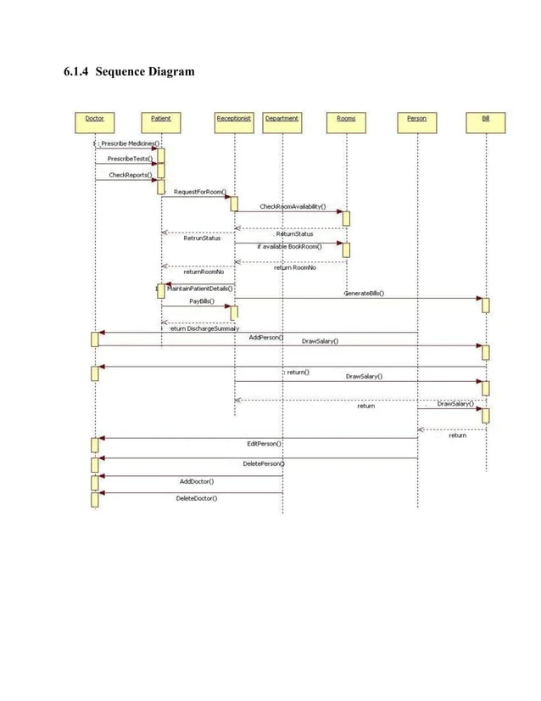

# ER DIAGRAM

# **Non-Functional Requirements**

# Security

**Patient Identification**

The system requires the patient to identify himself /herself using PIN

**Logon ID** Any user who uses the system shall have a Logon ID and Password.

**Modification** Any modification (insert, delete, update) for the Database shall be synchronized and done only by the administrator in the ward.

**Front Desk staff Rights** Front Desk staff shall be able to view all information in HPIMS, add new patients to HPIMS but shall not be able to modify any information in it.

**Administrators ' Rights** Administrators shall be able to view and modify all information in HPIMS.

# Safety Requirements

If there is extensive damage to a wide portion of the database due to catastrophic failure, such as a disk crash, the recovery method restores a past copy of the database that was backed up to archival storage and reconstructs a more current state by reapplying or redoing the operations of committed transactions from the backed-up log, up to the time of failure.

# Performance Requirements

**Response Time** The system shall give responses in 1 second after checking the patient’s information.

**Capacity** The System must support 1000 people at a time.

**User-interface** The user-interface screen shall respond within 5 seconds.

**Conformity** The systems must conform to the Microsoft Accessibility guidelines.

# Maintainability

**Back Up** The system shall provide the capability to back-up the Data

**Errors** The system shall keep a log of all the errors.

# Reliability

**Availability** The system shall be available all the time

# Business Rules

* Want take the responsibility of failures due to hardware malfunctioning.
* Warranty period of maintaining the software would be one year.
* Additional payments will be analysed and charged for further maintenance
* If any error occur due to a user’s improper use. Warranty will not be allocated to it. ▪ No money back returns for the software.
* Trust bond placement should be done before designing and coding. An advance or an Agreement.
* **Patient registration:** A new patient must provide their personal and contact information, including name, address, phone number, and insurance information, in order to be registered in the system.
* **Unique patient ID:** Each patient must be assigned a unique ID that is generated by the system and can be used to identify and retrieve the patient's information.
* **Access control:** Only authorized personnel, such as administrators and receptionists, can access the system and add or modify patient data.
* **Data privacy:** Patient information must be protected and kept confidential, with strict access controls in place to prevent unauthorized access or misuse of data.
* **Average length of stay:** The system must be able to calculate and track the average length of stay for patients, from the time they are admitted to the time they are discharged.
* **Time to service:** The system must be able to track and measure the time it takes for patients to receive healthcare services after they arrive at the hospital.
* **Hospital incidents:** The system must be able to track and measure incidents that occur within the hospital, such as adverse events or medical errors, in order to improve the quality of care provided.
* **Patient satisfaction:** The system must be able to gather and track patient satisfaction data in order to assess the overall quality of care provided by the hospital.
* **Patient readmission rate:** The system must be able to track and measure the number of patients who are readmitted to the hospital after being discharged.

# Testability Requirements

**Functional testing:** This would involve testing each individual module of the HMS to ensure that it is functioning correctly and meeting the requirements specified in the software requirement specification (SRS) document.

**User acceptance testing:** This would involve testing the HMS with a group of users, such as hospital staff, to ensure that the system is user-friendly and meets their needs.

**Performance testing:** This would involve testing the HMS to ensure that it can handle the expected number of users and transactions without experiencing any performance issues, such as slow load times or system crashes.

**Security testing:** This would involve testing the HMS to ensure that it is secure and meets the necessary regulations regarding data protection and privacy.

**Integration testing:** This would involve testing the HMS to ensure that it integrates seamlessly with other systems used by the hospital, such as electronic health record (EHR) systems.

**Regression testing:** This would be done to ensure that any new changes made to the system don't break existing features.

**Continuous monitoring:** This would involve continuous monitoring of the system to ensure that it is working smoothly and quickly rectify any issues.

# Usability Requirements

**Time on task:** This measures the time it takes for a user to complete a specific task within the HMS, such as registering a patient. A shorter time on task indicates a more efficient and user-friendly system.

**Task completion rate:** This measures the percentage of users who are able to successfully complete a specific task within the HMS, such as searching for a patient's information. A higher task completion rate indicates a more usable system.

**Error rate:** This measures the number of errors made by users while interacting with the HMS, such as incorrectly entering information. A lower error rate indicates a more usable system.

**Learnability:** This measures how quickly and easily a user can learn how to use the HMS. A more learnable system is one that is more usable.

**Satisfaction:** This measures the users' level of satisfaction with the HMS. A high level of satisfaction indicates a usable system.

**Recall:** This measures the extent to which users can remember how to use the system after some time, indicating that the system is easy to remember and use

**Users' feedback:** This measures the feedback of the user and their suggestion to improve the system which can be implemented to make it more usable.

# Documentation Requirements

**Software requirements specification (SRS):** This document should clearly define the functional and non-functional requirements of the HMS, including user needs, system performance requirements, and any legal or regulatory compliance requirements.

**User manual:** This document should provide users with detailed instructions on how to use the HMS, including step-by-step instructions for performing various tasks within the system.

**Technical documentation:** This should include information about the system's design, architecture, and implementation, and may include information about the system's code, databases, and APIs.

**Test documentation:** This should include information about the test cases, results, and defects that were identified during the testing phase of the project.

**Maintenance documentation:** This should include information on how to maintain and update the system, including troubleshooting and known bugs.

**Release notes:** This should contain information about new features, changes and bug fixes that were implemented in each release, and what the user can expect from them.

**User guidelines:** This should include information about best practices and common use cases of the system to make user's experience better.